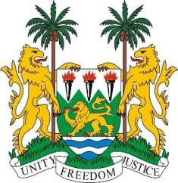
SIERRA LEONE
22nd Session of the UPR

HONDURAS

8 May 2015

Mr President,

Sierra Leone welcomes the Honduras delegation and thanks them for the update of their national report.

Honduras has shown its commitment to human rights promotion and protection by ratifying the core international human rights instruments; by amending its Criminal Code to more effectively address challenges identified in the first cycle of the UPR; establishing a Ministerial Portfolio for Human Rights and by establishing a Policy and National Action Plan on Human Rights, which aims at mainstreaming human rights perspectives into all state actions. Honduras has also implemented over 80 per cent of the recommendations of the Truth and Reconciliation Committee, enacted various legislations and set up an impressive number of mechanisms.

We urge Honduras to provide incentives to ensure the access by the poor, marginalised and vulnerable communities, to free education provided within their communities.

In addition, my delegation would encourage Honduras to implement laws prohibiting hate crimes and violence against women and girls of African descent.

Sierra Leone has the following recommendations:

- Submit the overdue report to the relevant UN treaty bodies.
- Strengthen normative standards and measures aimed at eliminating domestic violence perpetuated against women.
- Further promote the participation of Afro-Hondurans and indigenous communities in the public sphere.
- Expedite the enactment and implementation of the Bill on the Protection of Journalists, Human Rights Defenders and Justice System Workers”, and provide adequate resources to establish an effective protection mechanism.

In conclusion, Sierra Leone would like to urge Honduras to provide funding or seek additional sources of funding for its various actions including human trafficking.

Sierra Leone would like to conclude by wishing Honduras a successful completion of their national review cycle.

Thank you, Mr President.

